|  |  |
| --- | --- |
| **Name** | Muhammad Asad |
| **Reg. No** | 2019-EE-383 |
| **Marks/Grade** |  |

**EXPERIMENT # 14**

**Modeling of Over-Frequency & Under-Frequency**

**Relay**

# Objective:

At the end of this lab session students will be able to

* Understand the working of frequency relay.
* Model frequency relay in Matlab Simulink.

# Introduction:

Frequency variations in the system occur due to the variation in the prime mover speed. In a large inter-connected stable system frequency variations are rare. Because a generator unit connected to a large stable system cannot operate at higher or lower frequency than the system frequency. But a smaller system or a generator working alone is prone to frequency variations due to the variations in load.

This abnormal condition is not very dangerous for the system. So frequency relay sense the abnormal condition and activate alarm and if this condition persist for a long time then relay operates the circuit breaker.

# Over-Frequency:

This condition is due to the increase in speed of prime mover. On the generation site this is protected by the over-speed device. An over-frequency relay can be used as backup to mechanical devices. Again, if the unit is connected to a stable system, the generator cannot operate above the system frequency. However, if the system is dynamically unstable over- frequency relays can alert the operator. In general, the governing devices will protect the unit from over-speed. But for reliable system all system conditions must be addressed.

# Under-Frequency:

While no standards have been established for abnormal frequency operation of generators, it is recognized that reduced frequency results large flux, saturation of magnetic material and large magnetization current. Therefore, operation at reduced frequency should be at reduced kVA or kV.

Operating precautions should be taken to stay within the short-time thermal ratings of the generator rotor and stator. Under-frequency is a system condition that affects the turbines and the transformers more than the generator.

# Frequency Relay:

The frequency relay activates alarm or isolates the generator in the case when frequency deviates from the allowable limits. As mentioned earlier the over and under frequencies are produced in a power system due to sudden change in load or generation. Over frequency can occur due to isolation of a large load by tripping of a transmission line. Under frequency can occur due to loss of one or more generating sources in a heavily loaded power system.

# Laboratory Task:

Implement a frequency relay that protects the system in over-frequency and under-frequency conditions.

# Procedure

**Step 1:**

Draw a power system having a three phase programmable source, three phase circuit breaker, three-phase VI measurement unit and three phase RLC series load. Connect the blocks as shown below.

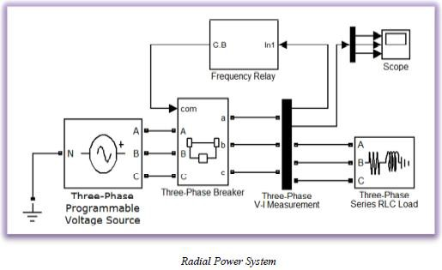

Set the properties of each block as mentioned below. Keep all other parameters as it is. System Frequency: 50 Hz

Total Simulation Time: 0.5 s

Solver: Ode23tb (stiff/TR-BDF2)

Solver reset Method: Robust

**Three phase programmable voltage source:**

Voltage (Phase to Phase): 11e3 V Frequency: 50

Time variation of: Frequency

Type of variation: Step

Step magnitude: 0

Variation timings: [0.18 0.4]

**Three-Phase Breakers:**

Initial status of breakers: closed

**Three-Phase Series RLC Load:**

Configuration: Y grounded Nominal voltage: 11e3

Active Power (W): 100e6 Inductive reactive power: 100 VAR Capacitive reactive Power: 0 VAR

**Step 2:**

In subsystem “Frequency Relay”, connect the blocks as shown in the diagram and set the parameters of all the blocks given in the diagram as specified below. To access the different blocks in the MATLAB SIMULINK library their full path has been given against their names.

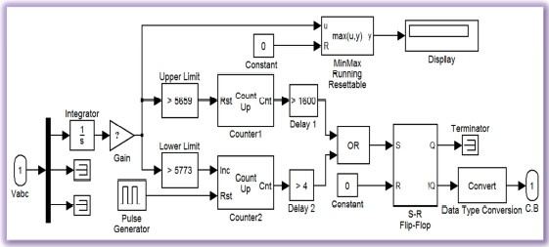

**Integrator:** *(Simulink >> Commonly Used Block)*

Initial condition: 0

This block is used to find the area under the curve. The area under the sinusoidal wave depends upon the frequency. Because with the increase in frequency wave shrinks on time axis and its area decreases and vice versa. It means the frequency of system can be judged from the

area under the curve. Observe the output of integrator on ‘scope’ along with the sinusoidal waveform.

Also draw these waveforms in the space given below.

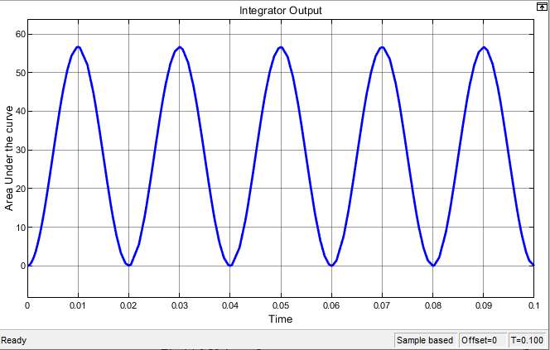

**Fig .1 show Integrator Output**

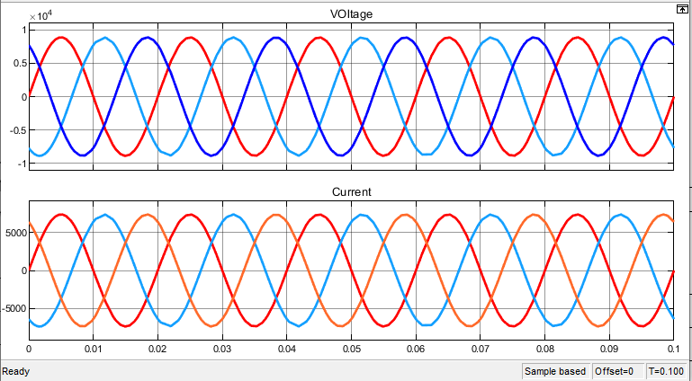

**Fig.2 show the V-I Output**

**Task 1:**

Make a frequency relay in MATLAB Simulink and find out values of area under the curve at different values of frequency.

# Simulink model:

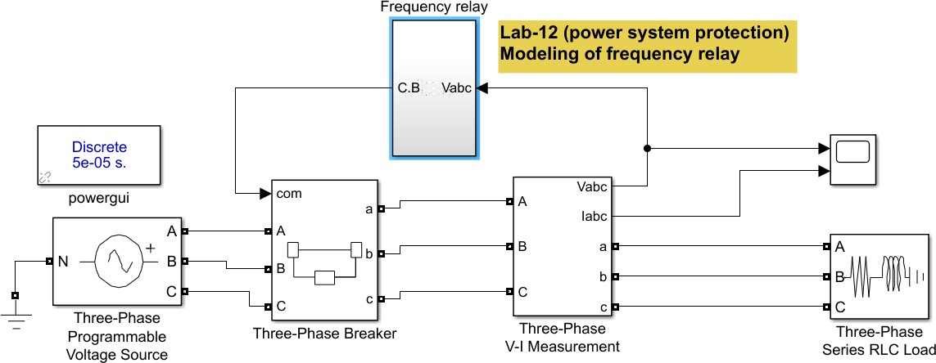

**Fig.3 show the implementation of frequency relay in power system**

# Frequency Relay model:

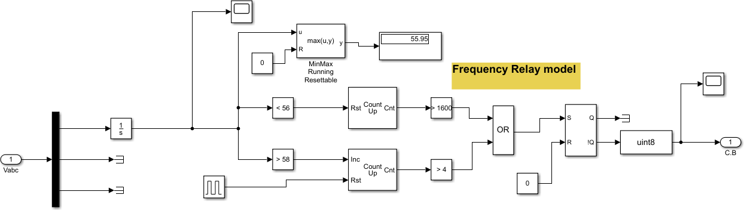

**Fig.4 frequency relay Simulink model Gain:** *(Simulink >> Commonly Used Block)*

This block is used to amplify the difference between the areas at two different frequencies. To set the value of gain, follow the instructions given below. For all the students, from Reg. No. 1 to 5 gain is 50 times of their roll number, from Reg. No. 6 to 25 gain is 10 times of their roll numbers, from Reg. No. 26 to 50 gain is 5 times of them roll numbers and for the rest of the student’s gain is equal to their roll number.

Gain = 70

Sample time: 50e-6

**MinMax Running Resettable:** *(Simulink >> Math Operations)*

Function: max

This block is used to determine the maximum value of input signal. It holds a value unless it is reset or some new higher value replaces the older one.

**Display:** *(Simulink >> Sinks)*

Format: bank

**Compare to Constant (Upper Limit & Lower Limit):** *(Simulink >> Logic and Bit Operations)*

To set the ‘constant value’ of these blocks run the simulation of the system at lower and upper limits of frequency by setting the frequency of ‘Programmable source’ to 49 Hz and 51 Hz

respectively, and observe the output of gain on ‘Display’. During this simulation keep the circuit

breaker permanently closed by applying a constant ‘1’ on its ‘com’ input. Note down the observations in the space given below. Output of ‘Gain’ at

49 Hz: ……**6559**…………, 50 Hz: ………**0**………., 51 Hz: …**6364**…….. Upper Limit (51 Hz): …**6559**………

Lower Limit (49 Hz): …**6364**………... Operator: ‘>’ (greater than)

*There is an inverse relation between frequency and area under the curve.*

Also note down the output on the ‘Display’ block for the following frequencies and draw a plot between frequency and corresponding area under the curve.

|  |  |  |  |  |  |  |  |  |  |  |  |
| --- | --- | --- | --- | --- | --- | --- | --- | --- | --- | --- | --- |
| **Frequency** | 45 | 46 | 47 | 48 | 49 | 50 | 51 | 52 | 53 | 54 | 55 |
| **Area (Max)** | 4515 | 4314 | 4223 | 4135 | 4050 | 3969 | 3891 | 3816.94 | 3744 | 3706 | 3640 |

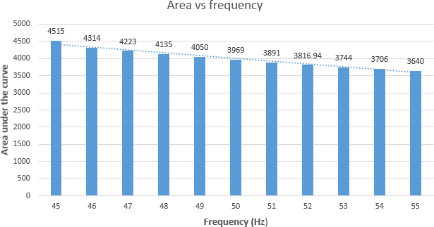

**Fig.5 show Area under the curve vs Frequency Graph**

**Counter (s):** *(Signal Processing Blockset >>Signal Management >> Switches and Counters)*

**Counter1:**

Count Direction: Up

Count Event: Free running

Count Size: User defined

Max. Count: 1e6

Initial Count: 0

Output: Count

Reset input: Check this option

Sample Time: 50e-6

**Counter2:**

Count Direction: Up

Count Event: Rising edge

Count Size: User defined

Max. Count: 1e6

Initial Count: 0

Output: Count

Reset input: Check this option

**Pulse Generator:** *(Simulink >> Sources)*

Pulse type: Time based

Time: Use simulation time

Amplitude: 1

Period: 0.1

Pulse width (%): 1

Time delay (sec) 0.099

Set the proper initial condition of ‘S-R Flip-Flop’

**Step 3:**

Simulate the system in following conditions by setting the parameters of ‘Three-Phase Programmable Voltage Source’.

|  |  |
| --- | --- |
| Frequency (in all conditions): | 50 Hz |
| **Normal Condition:** |  |
| Step magnitude: | 0 |
| **Over Frequency:**  Step magnitude: | 1.5 |
| **Under Frequency:**  Step magnitude: | -1.5 |
| **Matlab Model:** |  |



**Fig .6 show the power system model with frequency relay protection**

# Frequency Relay:

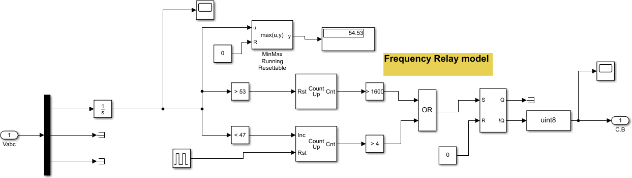

**Fig.7 show Matlab Simulink model of Frequency Relay**

# Integrator output:

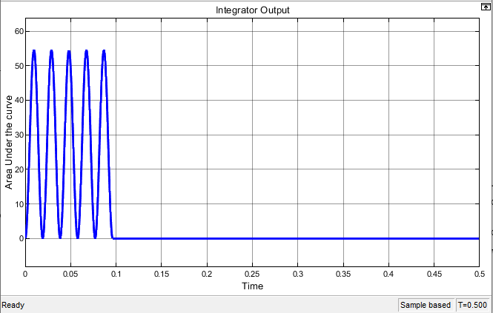

**Fig.8 show the Integrator Output in over frequency condition**

# Relay signal:

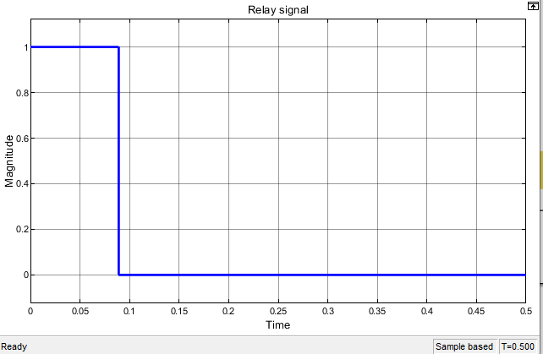

**Fig.9 show the relay tripping signal when fault occur**

# Over Frequency tripping (V-I waveform):

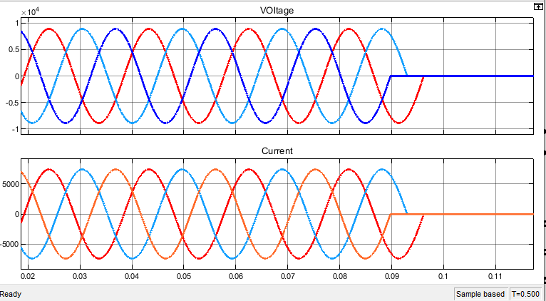

**Fig .10 show the Over Frequency V-I Outputs**

# Under Frequency tripping waveform (V-I waveform):

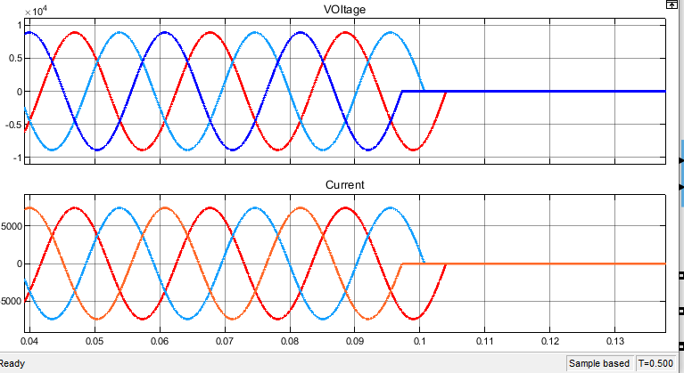

**Fig.11 show Under Frequency V-I Outputs**

# Integrator output:

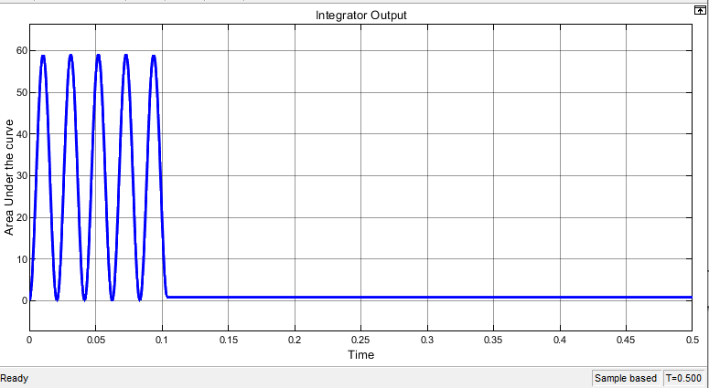

**Fig.12 show the Integrator Output in under frequency condition**

# Relay signal:

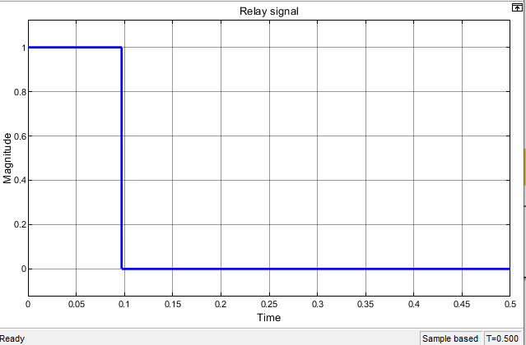

**Fig.13 show the relay tripping signal when fault occur**

**CONCLUSION:**

In this lab, we learn about the Over and under frequency relay by using MATLAB Simulink. First, we make a three phase power system and Relay model in MATLAB. Initially, we set breaker closed and find out the two frequency limits for over and under frequency condition and also find the Area under the curve for different frequency values. When we increase frequency in programmable source (+1.5). Relay detect it as abnormal condition and send signal to breaker. When set frequency value (-1.5), it falls down from low range frequency value and under frequency relay detect this abnormal condition and sends signal to breaker for tripping. All this is done by comparing frequency value with Area under the curve as both has inverse relation. In over frequency, Area under the curve decrease and increase in case of under frequency condition. We also made a graph of frequency vs. are under curve which showed inverse relationship. We implement this phenomenon in relay setting and find out the results. We The results and graphs were shown above.